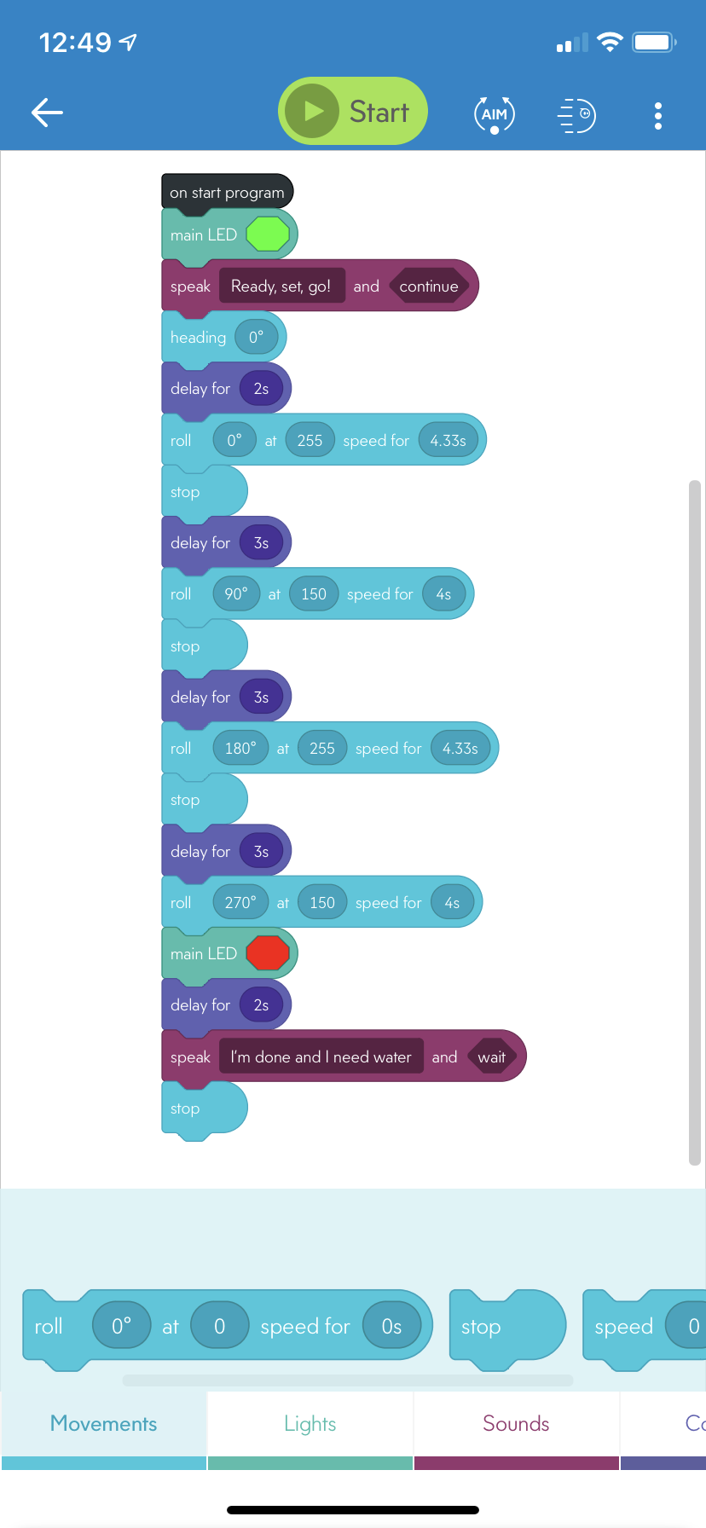

async function startProgram() {

setMainLed({ r: 47, g: 255, b: 25 });

await speak('Ready, set, go!', false);

setHeading(0);

await delay(2);

await roll(0, 255, 4.33);

stopRoll();

await delay(3);

await roll(90, 150, 4);

stopRoll();

await delay(3);

await roll(180, 255, 4.33);

stopRoll();

await delay(3);

await roll(270, 150, 4);

setMainLed({ r: 255, g: 1, b: 0 });

await delay(2);

await speak('I’m done and I need water', true);

stopRoll();

}